 | 12.1.21 Editors - Geometry Nodes Editor - Header - Add Menu - Volume
Table of content
Detailed table of content 1
Add menu - Volume 1
Points to Volume 2
Volume to Mesh 2
Legacy - Volume 3
Points to Volume 3

Detailed table of content
Detailed table of content
Detailed table of content 1
Add menu - Volume 2
Points to Volume 2
Inputs 2
Geometry 2
Density 2
Voxel Amount 2
Radius 2
Properties 2
Resolution 2
Output 2
Geometry 2
Volume to Mesh 2
Inputs 3
Geometry 3
Density 3
Threshold 3
Adaptivity 3
Properties 3
Resolution 3
Output 3
Geometry 3
Legacy - Volume 3
Points to Volume 3
Inputs 4
Geometry 4
Density 4
Voxel Amount 4
Radius 4
Properties 4
Resolution 4
Radius 4
Output 4
Geometry 4

Add menu - Volume
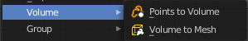
Here you find nodes to modify the volume.

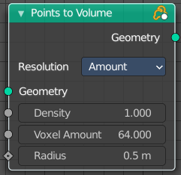
Points to Volume
Creates a fog volume sphere around every point in the input geometry. The new volume grid is then called density.

Inputs

Geometry
Standard geometry input.

Density
The density of the point cloud.

Voxel Amount
The voxel amount to use.

Radius
The radius of the generated volume around each point.

Properties

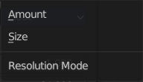
Resolution
Base the voxel resolution at the amount or the size of the point cloud.

Output

Geometry
Standard geometry output.

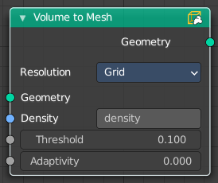
Volume to Mesh
The Volume to Mesh node generates a mesh on the “surface” of a volume. The surface is defined by a threshold value. All voxels with a larger value than the threshold are considered to be outside.
Note that currently this node only works on volumes generated using geometry nodes.

Inputs

Geometry
Standard geometry input.

Density
The density input of the volume object. Either a tag or the information from another node.

Threshold
The voxel amount to use.

Adaptivity
The input radius.

Properties

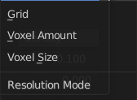
Resolution
Base the voxel resolution at the gridsize, the amount or the size of the point cloud.

Output

Geometry
Standard geometry output.

Legacy - Volume

These nodes existed in a former Bforartists version, but are now deprecated. They do not show in the regular menu or UI anymore. And you cannot insert them in a newer Bforartists version. But old projects that uses this nodes still loads with these nodes showing and enabled.

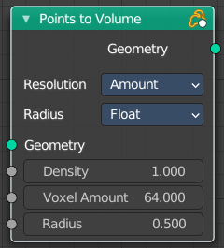
Points to Volume
Creates a fog volume sphere around every point in the input geometry. The new volume grid is then called density.

Inputs

Geometry
Standard geometry input.

Density
The density of the point cloud.

Voxel Amount
The voxel amount to use.

Radius
The radius of the generated volume around each point.

Properties

Resolution
Base the voxel resolution at the amount or the size of the point cloud.

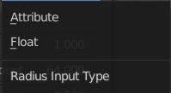
Radius
The type of the radius input.

Output

Geometry
Standard geometry output.

